**Spring 2011 - Curb Appeal Feb 15 2011**

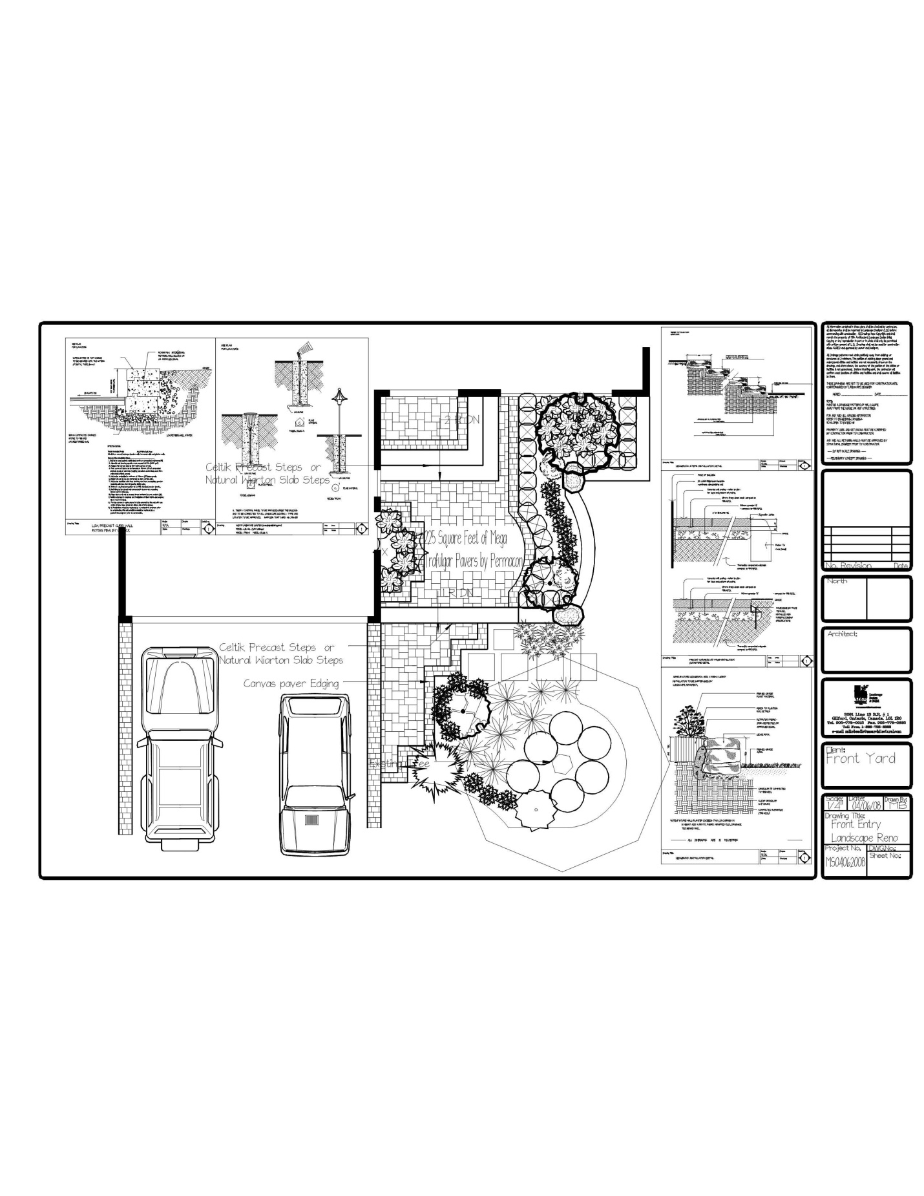 If you looked outside this morning and saw the temperature you would think winter is never going to end. As the temperatures begin to tease us with coming above zero, we get a sense that spring is just around the corner. No more hats, coats, boots and shovelling snow. As we ponder the warmer days of spring and think of our gardens where do we start? Last spring addition we looked at the bed rejuvenation. This year we are going to take a little harder look the needed facelift to our front yard landscape and garden. If you’ve ever gone done the street and referred to the home on the next block that has that “inviting feel and warming entrance” we are going to attempt to give you the tools and resources here to sit down and begin to plan this.

Let’s start with the foundation of this appeal, your walkway. With most subdivision homes and fronts today we are dealing with an elevation change of steps and landings. From the driveway we want the walkway to lead us comfortable, securely and welcome us to your front door. As in most homes the door is situated along the long wall of the garage and the builder has left us with 15-20 patio slabs laid against this wall leading to 4 precast steps. We will begin in the layout to pull the walkway down the driveway towards the street allowing easy access from the vehicle and also providing a comfortable walkway width extending the hard surface and giving us the entrance to our home. As this walkway continues to move and take us along we then pull the walkway away from the garage wall and allow the walkway to center our sights on the front door and the welcoming environment of our home. This is done if room allows you to create a small bed against the wall of the garage. Pulling the walk over while still providing a safe and balanced walk. One thing that most people at this point make a mistake of is planting. They have already in their minds headed to the nursery and bought that cute shrub that has been grown in a container and is about 18” tall. READ THE LABEL! Even a dwarf shrub when you read the mature sizing growth will outgrow this location. This bed will be used for small hedging (boxwoods), perennial ground cover, dwarf ornamental grasses or annual and seasonal planting. If space is really limited we will use paving and plan urns and feature planting pots to soften and give this appeal.

The next challenge is dealing with the elevation in our planning of renovation. Your design shape will also have to be considered if you are linear or random in shape, ensure that your stairs flow with the walkway and are always square to the direction of the flow of the walkway. Stairs can add interest, shape and elevation transition that enhances the look. It can also add a maintenance and safety problem in time when not properly thought out or properly selecting the materials that are best suited for the project. In designing the step configuration look at balance of steps and landings to give you an easy walk. My preference when dealing with stairs is to make 2 even landings. In homes with large elevation changes you will need to consider a straighter run and hand railings. In the building code the moment you put 3 steps together you are required to install a hand railing. Hand railings are always advisable for safety but not always required.

Once the foundation of your walkway and stairs is complete you are now ready to begin to select the materials. Do not forget to pre-plan for future landscape lighting and irrigation at this point by properly planning the installation of conduits under your walkways for future work. I am not going to spend allot of time on this at this point but the following considerations are going to be looked at. What is the most suitable product for the proposed design, aesthetics of the visual theme, precast verse natural stone, dry laid or on concrete foundation? All considerations will govern your project but most people find cost to be the deciding factor. A BIG TIP HERE, that home you have passed and admired the look of chances are they have not put cost ahead of the right products for the project. Rather than just getting it done and moving on consider staging the project to allow you the freedom to complete the project properly and with the best look possible rather than the attitude of just getting it done!

Remember in today’s market that most people spend $15,000.00 on a complete bath room renovation that is hidden within the house and average area is less than 100 square feet. Most front walkways are 150-200 square feet and do not get the same consideration. Also a point to ponder in your front entrance, what is your first impression? Whether in selling, street appeal or as people come to your home what is the impression your front entrance gives? You be the judge.

Now we are ready to start the bed and plant materials layout. With the elevation and design it is time to plan the finished plant materials and need for retaining walls. In the design of your walkway it will dictate the need for walls or terraced rockery. The formal and clean appearance of a linear design lends itself to beautiful stone walls. With larger entrances you are able to terrace and use the beautiful weathered natural rockery. Your landscape designer will be able to help you with this selection. At this point I strongly recommend a landscape professional.

Planting is the completion of this project. I hear of so many people that go shopping on an empty stomach and buy on impulse of colour and visual look at that point in time. Remember that the nursery has forced certain plant material to bloom in order to make a marketable appearance. You need to know the flowering times, colour, light requirements, and heat zone dependencies for your specific area, watering requirements, and height and width requirements of plants. This is not an easy task. In the elevations we have created above you want you plant materials to highlight this with the grandest of effects. Your soil is also a key factor to your planting success. I recommend you use a quality soil that will give your plants the nourishment and habitat for your plants to thrive. Clifford’s Haulage featured in this magazine is a great resource for your soil needs.

The last considerations are your landscape lighting and irrigation. Do not leave this out at the initial stages as you will need this and need to provide allowances for this for future completion if the budget does not allow this at the initial construction. Mike Beadle of M&S Architectural Ltd runs and operates a design build landscape construction company that specializes in residential landscape visit them at [www.msarchitectural.com](http://www.msarchitectural.com)